SOUTH EAST LINCOLNSHIRE
MONITORING REPORT

1st April 2013 – 31st March 2014

Contents

1 Introduction 3
2 Background Information 5
3 Housing 11
4 Economy 27
5 Environment 34

Tables
Table 1: Population changes 2001–2013 5
Table 2: Age Structure 2011 5
Table 3: Highest Qualification Attained 6
Table 4: Industry of Employment 7
Table 5: Earnings by Place of Work 7
Table 6: Car or Van ownership rates 8
Table 7: Mode of Travel to work in Lincolnshire (people aged 16-74 in employment) 8
Table 8: Registered Parks and Gardens, Conservation Areas, Scheduled Monuments and Listed Buildings (Grade I and II*) on the Heritage at Risk Register 10
Table 9: Boston Borough Housing Targets 11
Table 10: South Holland District Housing Targets 11
Table 11: Managed Delivery Target for Boston Borough 12
Table 12: Boston Borough Housing Trajectory 14
Table 13: Managed Delivery Target for South Holland District 15
Table 14: South Holland District Housing Trajectory 17
Table 15: Dwellings built on previously developed land 18
Table 16: Net additional Gypsy and Traveller pitches in South East Lincolnshire 18
Table 17: Net affordable housing completions in South East Lincolnshire 19
Table 18: Housing appeal decisions in South East Lincolnshire 25
Table 19: Employment floorspace (m²) completed 28
Table 20: Employment floorspace (m²) completed on previously developed land 28
Table 21: Total amount of new employment land (including allocated land with no planning permission and land with planning permission not started) 28
Table 22: Total amount of floorspace for town centre uses end March 2013 29
Table 23: Allocated employment land with no planning permission end March 2013 29
Table 24: Allocated and non-allocated employment land with planning permission (Ha) in Boston Borough 29
Table 25: Allocated and non-allocated employment land with planning permission (Ha) in South Holland District 30
Table 26: Floorspace on allocated and non-allocated employment land with planning permission (m²) in Boston Borough 30
Table 27: Floorspace on allocated and non-allocated employment land with planning permission (m²) in South Holland District 30
Table 28: Number of vacant ground floor units within Town Centres 31
Table 29: Number of A1 units in primary shopping frontages 31
Table 30: Number of planning permission granted contrary to Environment Agency advice 34
Table 31: Renewable energy generation in South East Lincolnshire 35
Table 32: Number of Listed Buildings in South East Lincolnshire by Grade 36
Table 33: Listed Buildings on the 2013 Heritage at Risk Register (including places of worship) 36
Table 34: Scheduled Monuments on the 2013 Heritage at Risk Register 37
Table 35: Housing permissions and completions across South East Lincolnshire in ROY zones 39

Figures
Figure 1: Boston Borough Housing Trajectory 13
Figure 2: South Holland District Housing Trajectory 16
Figure 3: Gross completions on Greenfield and Brownfield sites 18
Figure 4: Total completions on allocated and non-allocated sites in Boston Borough 19
Figure 5: Total completions on allocated and non-allocated sites in South Holland District 20
Figure 6: Total commitments on allocated and non-allocated sites in Boston Borough 20
Figure 7: Total commitments on allocated and non-allocated sites in South Holland District 21
Figure 8: Urban and rural housing completions in Boston Borough 21
Figure 9: Urban and rural housing completions in South Holland District 22
Figure 10: Average density of housing on large schemes completed in Boston Borough 22
Figure 11: Average density of housing on large schemes completed in South Holland District 23
Figure 12: Average density of housing on large schemes approved in Boston Borough 23
Figure 13: Average density of housing on large schemes approved in South Holland District 24
Figure 14: Number of bedrooms in completed dwellings (Boston Borough) 24
Figure 15: Number of bedrooms in completed dwellings (South Holland District) 25
Figure 16: Hourly pedestrian traffic through Strait Bargate on Wednesday market day 32
Figure 17: Occupancy of Boston’s town centre car parks in October 32
Figure 18: Total tonnage of grain, timber, steel, paper and other products handled by the Port of Boston 33
Figure 19: Flood-hazard classification used in the Lincolnshire Coastal Study 38

1 Introduction

1.1 This Monitoring Report has been prepared by the South East Lincolnshire Joint Policy Unit for the Joint Strategic Planning Committee which covers the constituent local planning authorities of Boston Borough and South Holland District. It covers the period 1st April 2013 to 31st March 2014 and is mainly concerned with monitoring the implementation of policies contained within the South Holland Local Plan (2006), the adopted Boston Borough Local Plan (1999) and the Boston Borough Interim Plan (2006).

1.2 It also covers;
- progress on preparing documents specified in the local development scheme;
- net additional dwellings (and net additional affordable dwellings);
- neighbourhood development orders;
- neighbourhood development plans;
- information specified in regulation 62(4) of the Community Infrastructure Levy (CIL) Regulations 2010 if the LPA prepare a report pursuant to the regulation; and
- action taken under the Duty to Co-operate.

1.3 Local Development Scheme

1.4 The Local Development Scheme (LDS) is a public statement setting out what planning documents are to be prepared locally (these are together referred to as the Local Plan) and the timetable for their production.

1.5 The LDS has three main roles:
- to create certainty for the public and stakeholders, informing them of the range of plans being produced, the timescales for producing them and the intended outcomes;
- to prioritise, programme and allocate resources for the preparation of plans; and
- to provide a framework and timetable for the review of plans

1.6 Following discussions between Boston Borough Council (BBC), Lincolnshire County Council (LCC) and South Holland District Council (SHDC) regarding the possibility of preparing a Joint Local Plan for the areas covered by BBC and SHDC, the three ‘partner authorities’ signed an agreement dated 12th January 2011 to provide and support a South East Lincolnshire Joint Strategic Planning Committee. This signed agreement was submitted to the Secretary of State for consideration and a Parliamentary Order establishing the Joint Committee came into force on 5th July 2011.

1.7 The Joint Strategic Planning Committee approved its third and latest LDS on 28th February 2014 and the document can be viewed online at -http://www.southeastlincslocalplan.org/local-development-scheme-3/

1.8 As at 31st March 2014, all LDS milestones had been met.

1.9 Neighbourhood Development Orders

1.10 A Neighbourhood Development Order can be prepared by a Town Council, Parish Council, or Neighbourhood Forum to grant planning permission for specified types of development within the neighbourhood area. Once an Order is in force, there is no need for anyone to apply for planning permission if it is for the type of development covered by the Order. No Neighbourhood Development Orders have been prepared in South East Lincolnshire during the monitored year and, as at 31st March 2014, no Neighbourhood Development Orders were in force.

1.11 Neighbourhood Development Plans

1.12 A Neighbourhood Plan can be drawn up by a Town Council, Parish Council, or Neighbourhood Forum to set out general planning policies for the development and use of land within the neighbourhood area. No Neighbourhood Development Plans have been prepared in South East Lincolnshire during the monitored year and, as at 31st March 2014, no Neighbourhood Development Plans were in force.

1.13 Community Infrastructure Levy

1.14 A Community Infrastructure Levy can be set by a local planning authority. It is a charge on development to help deliver infrastructure to support the development of the area. As at 31st March 2014, no Community Infrastructure Levy had been set in South East Lincolnshire.

1.15 Action taken under the Duty to Co-operate:

1.16 To date the South East Lincolnshire Joint Policy Unit has;
- consulted with all the relevant duty to co-operate partners as part of the statutory consultation of the South East Lincolnshire Local Plan Strategy and Policies DPD - Combined Preferred Options and Sustainability Appraisal Report;
- included the Environment Agency (EA) as a partner on the South East Lincolnshire Local Plan Steering Group, as well as met with EA representatives on a number of occasions to discuss specific policy issues relating to development in areas at risk of flooding;
- held meetings and exchanged correspondence with Central Lincolnshire Joint Policy Unit and East Lindsey District Council with the duty to co-operate as the primary business;
- worked with South Holland District Council’s partners (South Kesteven District Council, Rutland County Council and Peterborough City Council) on the preparation of the Peterborough Sub-Region Strategic Housing Market Assessment Update;
- worked on producing the Coastal Lincolnshire Strategic Housing Market Assessment Update (Boston Borough Council and East Lindsey District Council);
- held meetings with respective councils involved in the SHMA process to discuss the duty to co-operate and meeting objectively assessed housing need; and
- hosted an Infrastructure Delivery Plan workshop with a number of key duty to co-operate partners including infrastructure and utility providers

1.17 It is recognised that the duty to co-operate is an ongoing exercise throughout the Local Plan preparation process and this list will be amended as and when evidence on the duty to co-operate arises.

2 Background Information

2.1 Population

2.2 South East Lincolnshire covers the areas of Boston Borough and South Holland District with an area of 110,392 hectares. The latest population estimate for the area is 155,113, and tables 1 and 2 below provide information on the demographic composition of the area, showing population change over the past thirteen years, and age structure in 2011.

Table 1: Population Change 2001 – 2013
Year | Boston Borough | South Holland
2001 | 55750 | 76522
2002 | 56600 | 78000
2003 | 57300 | 79600
2004 | 58500 | 81000
2005 | 58800 | 81600
2006 | 59000 | 82100
2007 | 59100 | 82600
2008 | 59100 | *83400
2009 | 59000 | 84100
2010 | 59000 | 84600
2011 | 64600 | 88300
2012 | 64615 | 88390
2013 | 65870 | 89243

Table 2: Age Structure 2011
Age Group | Boston Borough | South Holland District | % Boston Borough | % South Holland District | % Lincolnshire | % England
0-4 | 3,800 | 4,300 | 5.9 | 5.1 | 5.2 | 6.2
5-9 | 3,200 | 4,200 | 5.0 | 4.9 | 4.9 | 5.6
10-14 | 3,500 | 4,800 | 5.4 | 5.7 | 5.7 | 5.8
15-19 | 3,700 | 4,700 | 5.7 | 5.5 | 6.2 | 6.3
20-24 | 3,900 | 4,300 | 6.0 | 5.1 | 5.8 | 6.8
25-29 | 4,400 | 4,500 | 6.8 | 5.3 | 5.5 | 6.8
30-34 | 3,900 | 4,400 | 6.0 | 5.3 | 5.2 | 6.6
35-39 | 3,900 | 5,100 | 6.0 | 6.0 | 5.8 | 6.7
40-44 | 4,400 | 6,000 | 6.8 | 7.0 | 7.0 | 7.3
45-49 | 4,500 | 6,400 | 7.0 | 7.5 | 7.5 | 7.3
50-54 | 4,200 | 5,700 | 6.5 | 6.6 | 6.8 | 6.4
55-59 | 4,100 | 5,400 | 6.3 | 6.3 | 6.4 | 5.7
60-64 | 4,400 | 6,400 | 6.8 | 7.5 | 7.4 | 6.0
65-69 | 3,700 | 5,300 | 5.7 | 6.2 | 6.3 | 4.8
70-74 | 3,000 | 4,700 | 4.6 | 5.4 | 5.0 | 3.9
75-79 | 2,400 | 3,900 | 3.7 | 4.4 | 3.9 | 3.2
80-84 | 1,900 | 2,900 | 2.9 | 3.3 | 2.9 | 2.4
85+ | 1,600 | 2,500 | 2.5 | 2.9 | 2.6 | 2.2
2.3 At the 2011 Census there were 64,600 households in South East Lincolnshire. The average household size currently stands at 2.4 people; this matches the average in England and Wales.

2.4 Economy

2.5 The 2011 Census identifies that at the time of the Census day (27 March 2011), 77,307 (69.5%) people of working age in South East Lincolnshire were economically active (either in employment or seeking employment). This is on par with the overall average of 69.4% in the East Midlands and 69.7% in England and Wales. However, Table 3 below shows that the area’s workforce is comparatively poorly qualified and skilled.

Table 3: Highest Qualification Attained
% of persons aged 16-64 (2011)
 | Boston Borough | South Holland | South East Lincolnshire | East Midlands | England and Wales
Level 1 Qualifications (%) | 14.5 | 15.3 | 14.9 | 13.9 | 13.3
Level 2 Qualifications (%) | 15.3 | 16.5 | 15.9 | 15.6 | 15.3
Apprenticeship  (%) | 3.3 | 3.7 | 3.5 | 4.0 | 3.6
Level 3 Qualifications (%) | 9.3 | 10.0 | 9.7 | 12.9 | 12.3
Level 4 Qualifications and above (%) | 15.1 | 15.8 | 15.5 | 23.6 | 27.2
Other qualifications (%) | 9.9 | 7.9 | 8.9 | 5.3 | 5.7
No Qualifications (%) | 32.7 | 30.8 | 31.8 | 24.7 | 22.7

2.6 The area’s abundance of high-quality agricultural land has generated significant employment in agriculture and food manufacturing and processing as shown in Table 4 below. This has given rise to a generally low-wage economy within the area (see Table 5).

Table 4: Industry of Employment
% of persons in employment by Industry (April 2011)
 | Boston Borough | South Holland District | South East Lincolnshire | East Midlands | England
Agriculture, forestry and fishing | 5.4 | 6.2 | 5.8 | 1.2 | 0.8
Mining and quarrying | 0.1 | 0.0 | 0.1 | 0.3 | 0.2
Manufacturing | 17.9 | 15.8 | 14.8 | 12.9 | 8.9
Electricity, gas, steam and air conditioning supply | 0.3 | 0.4 | 0.4 | 0.8 | 0.6
Water Supply | 0.8 | 0.7 | 0.8 | 0.8 | 0.7
Construction | 6.0 | 7.8 | 6.9 | 7.7 | 7.7
Wholesale and retail trade, repairs | 20.1 | 20.8 | 20.5 | 17.8 | 15.9
Transport and storage | 5.2 | 6.6 | 5.9 | 5.2 | 5.0
Accommodation and food services | 4.2 | 3.6 | 3.9 | 5.1 | 5.6
Information and Communication | 1.0 | 1.5 | 1.3 | 2.6 | 4.1
Financial and Insurance activities | 1.1 | 2.1 | 1.6 | 2.5 | 4.4
Real estate activities | 1.1 | 0.9 | 1.0 | 1.1 | 1.5
Professional, scientific and technical activities | 2.6 | 4.3 | 3.5 | 5.0 | 6.7
Administrative and support services | 6.4 | 6.0 | 6.2 | 4.5 | 4.9
Public administration and defence | 3.4 | 3.6 | 3.5 | 5.6 | 5.9
Education | 6.5 | 6.7 | 6.6 | 9.9 | 9.9
Human health and Social work activities | 14.6 | 9.4 | 12.0 | 12.6 | 12.4
Other | 3.3 | 3.6 | 3.5 | 4.4 | 5.0

Table 5: Earnings by Place of Work
Gross mean pay (2012)
 | Boston Borough | South Holland District | South East Lincolnshire | East Midlands | Great Britain
Weekly pay | £404.70 | £412.90 | £408.80 | £464.40 | £507.60
Hourly pay | £9.74 | £9.49 | £9.62 | £11.55 | £12.87

2.7 Transport

2.8 Table 6 below shows that car or van ownership rates in South East Lincolnshire have increased between 2001 and 2011, and that car/van ownership is more prevalent in South Holland District than Boston Borough. Compared to the national average (32.2%), South Holland District has a greater proportion of households with more than one car or van (41.1% in 2011), whilst Boston Borough is broadly similar (33.2%). Both Boston Borough (20.8%) and South Holland District (14.6%) have a lower proportion of households with no car or van compared to the national average (25.6%), reflecting reliance on car travel in rural areas.

Table 6: Car or Van Ownership Rates
 |  | Boston Borough 2001* | Boston Borough  2011** | South Holland District 2001* | South Holland District 2011** | Lincs  2011 % | England and Wales 2011%
Total Number of Households |  | 23,992 | 27,291 | 32,752 | 37,264 | 100.0% | 100.0%
 | Households with 0 car | 5,221  (21.8%) | 5,667  (20.8%) | 5,276  (16.1%) | 5,442  (14.6%) | 18.0% | 25.6%
 | Households with 1 car | 11,802  (49.2%) | 12,561  (46.0%) | 15,658  (47.8%) | 16,499  (44.3%) | 44.8% | 42.2%
 | Households with more than 1 car | 6,969  (29.0%) | 9,063  (33.2%) | 11,818  (36.1%) | 15,323  (41.1%) | 37.2% | 32.2%

2.9 Table 7 (below) shows that the proportion of people travelling to work by car (as either driver or passenger) in both Boston Borough and South Holland District is greater than the national average, and that the use of public transport is considerably lower. This illustrates the rural nature of the area and the lack of sufficient public transport provision to provide an alternative to the car for many people. Interestingly, however, the percentage of people travelling by bicycle is higher than the national average, most notably in Boston Borough where it is 4.1%.

Table 7: Mode of Travel to work in Lincolnshire (people aged 16-74 in employment)
 | Boston Borough 2011 % | South Holland District 2011 % | Lincolnshire 2011 % | England and Wales 2011 %
Driving a Car or Van | 38.9 | 43.1 | 39.6 | 35
Passenger in a car or van | 7.3 | 4.2 | 3.9 | 3.2
Public Transport | 1.5 | 1.6 | 2.3 | 10.2
Bicycle | 4.1 | 2.7 | 2.5 | 1.8
On Foot | 5.8 | 4.5 | 6.8 | 6.3
Work from Home | 6.3 | 8.1 | 7.8 | 6.9

2.10 Natural Environment

2.11 South East Lincolnshire is characterised by flat fertile fenland that supports a large agricultural industry. The area is rich in wildlife with major areas of significant habitats including The Wash. There are also a number of Local Wildlife Sites (LWS) designated by the former Lincolnshire Biodiversity Partnership and its replacement, the Greater Lincolnshire Nature Partnership, as well as Frampton Marsh and Freiston Shore which are Royal Society for the Protection of Birds (RSPB) reserves. There are also four Local Nature Reserves (LNRs) - The Vernatt’s, Witham Way Country Park, Havenside Country Park and The Shrubberies. It is the aim of the Councils and Local Plan policies to ensure that a diversity of environments and landscapes are protected and enhanced.

2.12 In addition to this, both Boston Borough and South Holland District Councils have duties and responsibilities under the Town and Country Planning Act, Government Regulations and Circulars to protect trees within their administrative areas in the interest of amenity. These duties and responsibilities extend to making Tree Preservation Orders (TPOs). As at 1st April 2014 there were 498 TPOs throughout South East Lincolnshire with the largest numbers to be found in towns.

2.13 Historic Environment

2.14 Both Councils are committed to the protection of the area’s cultural heritage in order to ensure that the historic fabric of the area is retained for future generations to enjoy. The preservation of the area’s historic features makes a positive contribution to the quality of life of the inhabitants and helps to attract visitors to the area. The cultural assets of South East Lincolnshire include listed buildings, conservation areas, historic parks and gardens, scheduled monuments and sites of archaeological significance.

2.15 In 2014, South East Lincolnshire contained the following designated historic assets:
- 2 Registered Parks and Gardens;
- 24 Conservation Areas;
- 43 Scheduled Ancient Monuments; and
- 1,021 Listed Buildings.

2.16 Table 8 below identifies the number and percentage of registered parks and gardens, conservation areas, scheduled monuments and listed buildings (grade I and II*) on the English Heritage’s Heritage at Risk Register 2013. A notable point is that the percentage of conservation areas ‘at risk’ in South Holland is above the national average. Also the percentage of Grade I and II* buildings ‘at risk’ across both areas is higher than the national average.

Table 8: Registered Parks and Gardens, Conservation Areas, Scheduled Monuments and Listed Buildings (Grade I and II*) on the Heritage at Risk Register (2013)
 | Boston Borough | South Holland District
Registered Parks and Gardens  (Number) | 0 | 0
Conservation Areas  (Number) | 2 | 2
Scheduled Ancient Monuments  (Number) | 1 | 4
Grade I and II* Listed Buildings (including places of worship at risk)  (Number) | 5 | 9

3 Housing

3.1 Both Boston Borough Council and South Holland District Council have responsibilities to ensure that sufficient housing is available to meet the local community’s needs. This chapter of the monitoring report examines the progress of housing developments in both Boston Borough and South Holland District over the period 1st April 2013 to 31st March 2014.

3.2 Although LPAs no longer have to report against Core Output Indicators( COIs), the following COIs will be used in this section;
- H1: Plan period and housing targets
- H2(a): Net additional dwellings – in previous years
- H2(b): Net additional dwellings – for reporting year
- H2(c): Net additional dwellings – in future years
- H3: New and converted dwellings on previously developed land
- H4: Net additional Gypsy and Traveller pitches
- H5: Gross Affordable housing completions

3.3 Other Local Indicators, which reflect important aspects of South East Lincolnshire, are included as follows:
- L1: The number of dwellings provided on allocated and non-allocated sites
- L2: Urban and rural housing completions
- L3: Density of new development
- L4: The mix of sizes of housing completed compared with the Strategic Housing Market Assessment (SHMA)
- L5: Number of housing applications allowed on appeal
- L6: Supply of specific deliverable housing sites

3.4 Core Output Indicators

3.5 Indicator H1 - Plan period and Housing targets identifies the source of the housing target used in the housing trajectory, and the total amount of housing to be delivered over the plan period. Table 9 and 10 below set out the housing targets contained in the East Midlands Regional Plan (Regional Plan) which was formally revoked by the Secretary of State on 12th April 2013.

Table 9: Boston Borough Housing Target:
 | Start of plan period | End of Plan period | Total housing required | Source of Plan target
H1 | 01/04/2006 | 31/03/2026 | 2,700 | Regional Plan.

Table 10: South Holland District Housing Target:
 | Start of plan period | End of Plan period | Total housing required | Source of Plan target
H1 | 01/04/2006 | 31/03/2026 | 7,400 | Regional Plan

3.6 Indicator H2 - Net additional dwellings is sub-divided into the following four separate components:
- H2(a): net additional dwellings – in previous years;
- H2(b): net additional dwellings – for the reporting year;
- H2(c): net target dwellings – in future years;

3.7 They examine recent and likely future levels of housing delivery, and make up the various remaining elements of a housing trajectory. The components of Indicator H2 are set out in Table 11, Figure 1 and Table 12 for Boston Borough and Table 13, Figure 2 and Table 14 for South Holland District.

Table 11: Managed delivery target for Boston Borough
Year |  | H2(a) | H2(b) | H2(c)
 |  |  |  | a) Net additions | b) Target
06/07 |  | 271 | - | - | -
07/08 |  | 503 | - | - | -
08/09 |  | 282 | - | - | -
09/10 |  | 128 | - | - | -
10/11 |  | 96 | - | - | -
11/12 |  | 91 | - | - | -
12/13 |  | 64 | - | - | -
13/14 |  | - | 175 | - | -
14/15 |  | - | - | 377 | 270
15/16 |  | - | - | 373 | 270
16/17 |  | - | - | 373 | 270
17/18 |  | - | - | 292 | 270
18/19 |  | - | - | 292 | 270
19/20 |  | - | - | 292 | 270
20/21 |  | - | - | 292 | 270
21/22 |  | - | - | 292 | 270
22/23 |  | - | - | 292 | 270
23/24 |  | - | - | 293 | 270
24/25 |  | - | - | 293 | 270
25/26 |  | - | - | 293 | 270

Figure 1: Boston Borough Housing Trajectory

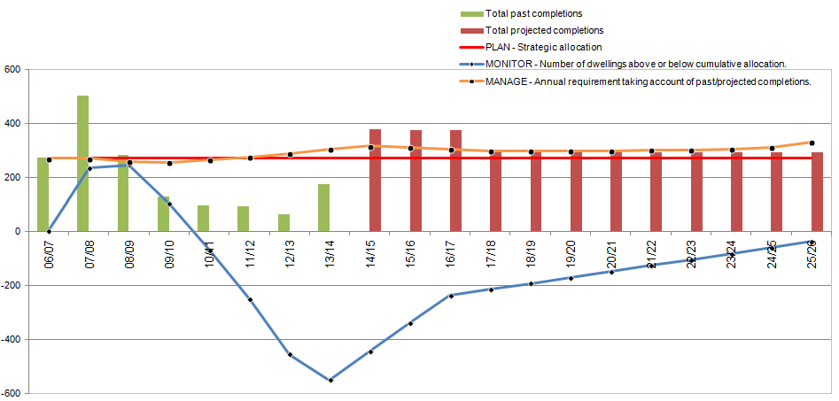

Table 12: Boston Borough Housing Trajectory
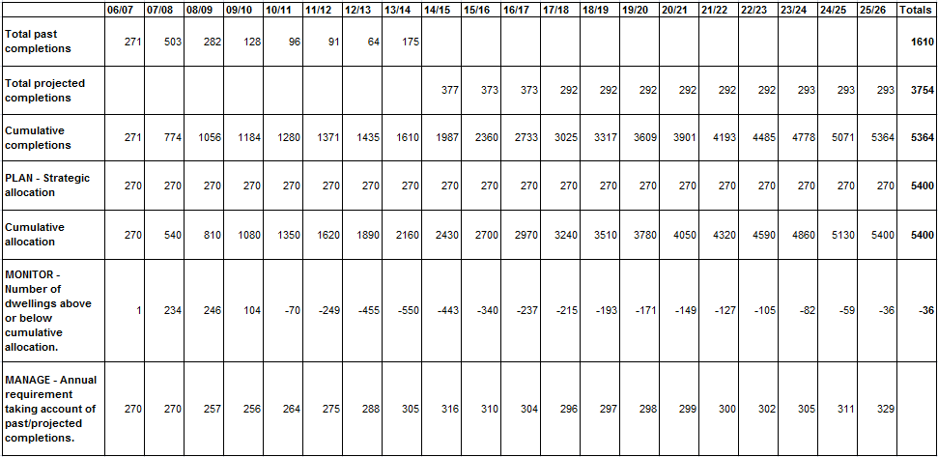

Table 13: Managed Delivery Target for South Holland District

Year |  | H2(a) | H2(b) | H2(c)
 |  |  |  | a) Net additions | b) Target
02/03 |  | 745 | - | - | -
03/04 |  | 697 | - | - | -
04/05 |  | 550 | - | - | -
05/06 |  | 515 | - | - | -
06/07 |  | 348 | - | - | -
07/08 |  | 560 | - | - | -
08/09 |  | 418 | - | - | -
09/10 |  | 282 | - | - | -
10/11 |  | 202 | - | - | -
11/12 |  | 167 | - | - | -
12/13 |  | 199 | - | - | -
13/14 |  | - | 254 | - | -
14/15 |  | - | - | 300 | 370
15/16 |  | - | - | 300 | 370
16/17 |  | - | - | 400 | 370
17/18 |  | - | - | 450 | 370
18/19 |  | - | - | 470 | 370
19/20 |  | - | - | 470 | 370
20/21 |  | - | - | 470 | 370
21/22 |  | - | - | 470 | 370
22/23 |  | - | - | 470 | 370
23/24 |  | - | - | 470 | 370
24/25 |  | - | - | 470 | 370
25/26 |  | - | - | 183 | 370

Figure 2: South Holland District Housing Trajectory
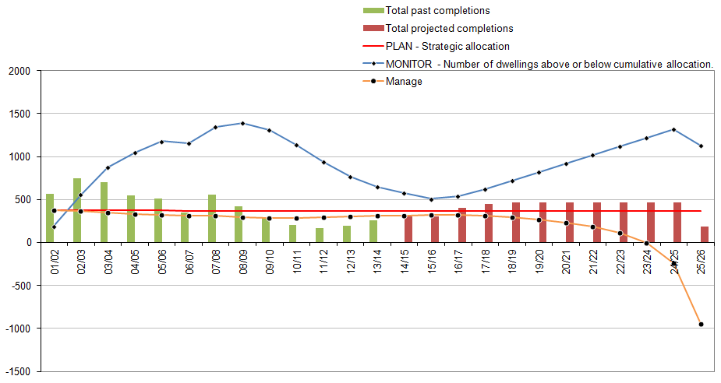

Table 14: South Holland District Housing Trajectory

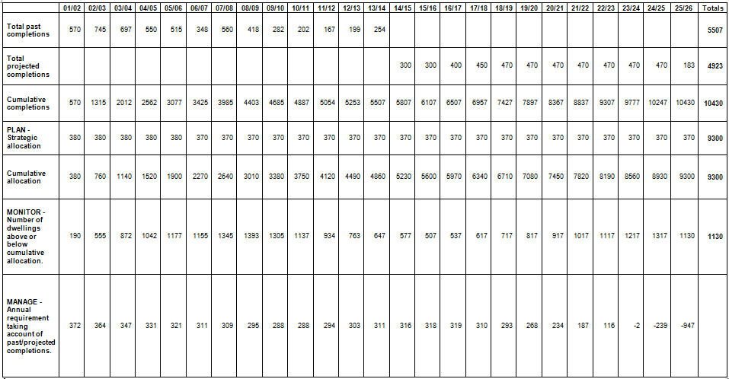
3.8 Indicator H3 - New and converted dwellings on previously developed land (PDL) identifies how many of the year’s new homes have been built on previously developed land (PDL) (often known as ‘brownfield’ land). Table 15 and Figure 3 below show that only one-third of new housing in South East Lincolnshire was delivered on brownfield sites during 2013/14. In more detail, 70% of Boston Borough’s development was on brownfield land, compared to 5% in South Holland District.

Table 15: Dwellings built on previously developed land (01/04/13 – 31/03/14)
 |  | Total
H3 | Number of dwellings built on previously-developed land | 134
 | Total number of dwellings built | 429
 | % on previously-developed land | 31%

Figure 3: Gross Completions on Greenfield and Brownfield sites (2004/05 – 2013/14)
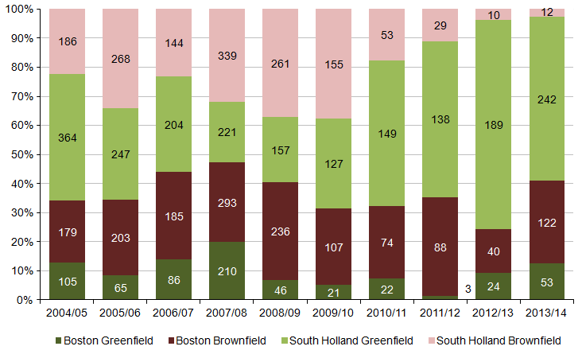

3.9 Indicator H4 – Net additional Gypsy and Traveller pitches identifies how many new Gypsy and Traveller pitches have been delivered in South East Lincolnshire during the monitored financial year (2013/14) and previous financial years.

Table 16: Net additional Gypsy and Traveller pitches in South East Lincolnshire
Year | Permanent | Transit | Total
2007/08 | 0 | 20 | 20
2008/09 | 0 | 0 | 0
2009/10 | 0 | 0 | 0
2010/11 | 0 | 0 | 0
2011/12 | 14 | 0 | 14
2012/13 | 12 | 0 | 12
2013/14 | 0 | 0 | 0
Total | 26 | 20 | 46

3.10 No additional pitches were provided during the monitored year.

3.11 Indicator H5 – Net affordable housing completions examines affordable housing delivery over the financial year. Table 17 (below) shows that within South East Lincolnshire affordable housing delivery has remained relatively high and a total of 115 affordable homes were delivered during 2013/14. This equates to 27% of all homes built in South East Lincolnshire.

Table 17: Net affordable housing completions in South East Lincolnshire

Year | Social Rent Homes Provided | Intermediate Homes Provided | Affordable Homes Delivered (Total)
2004/05 | 37 | 0 | 37
2005/06 | 75 | 6 | 81
2006/07 | 87 | 57 | 144
2007/08 | 117 | 79 | 196
2008/09 | 73 | 46 | 119
2009/10 | 78 | 38 | 116
2010/11 | 141 | 47 | 188
2011/12 | 87 | 58 | 145
2012/13 | 17 | 70 | 87
2013/14 | 76 | 39 | 115

3.12 Local Indicators

3.13 Indicator L1 - The number of dwellings provided on allocated and non-allocated sites examines the relative importance of allocated and non-allocated sites in meeting both Boston Borough’s and South Holland District’s housing needs.

Figure 4: Total completions on allocated and non-allocated sites in Boston Borough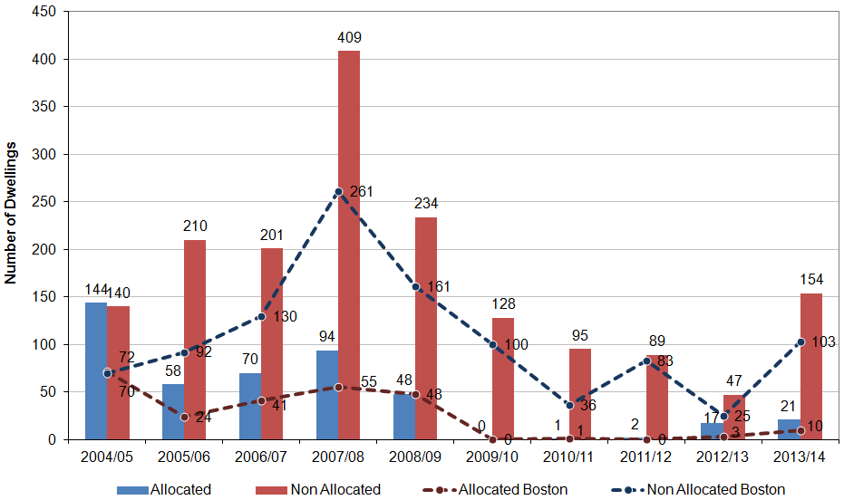

Figure 5: Total completions on allocated and non-allocated sites in South Holland District
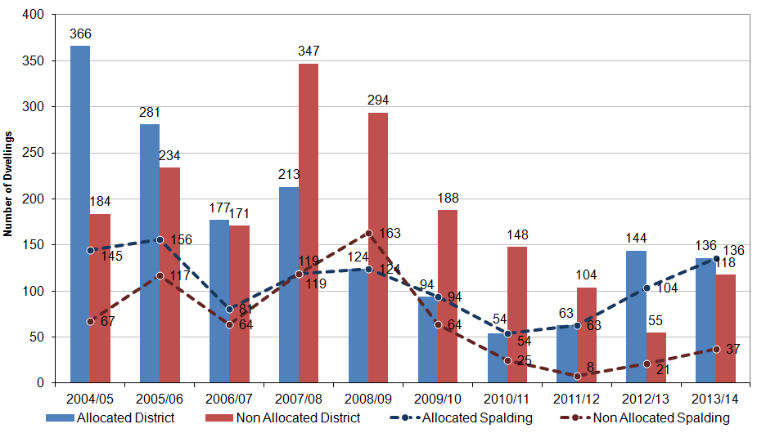

Figure 6: Total commitments on allocated and non-allocated sites in Boston Borough
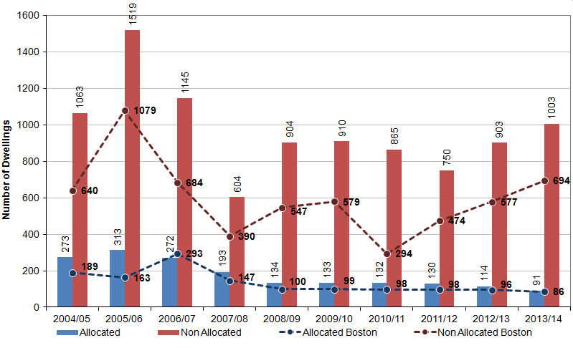

Figure 7: Total commitments on allocated and non-allocated sites in South Holland District
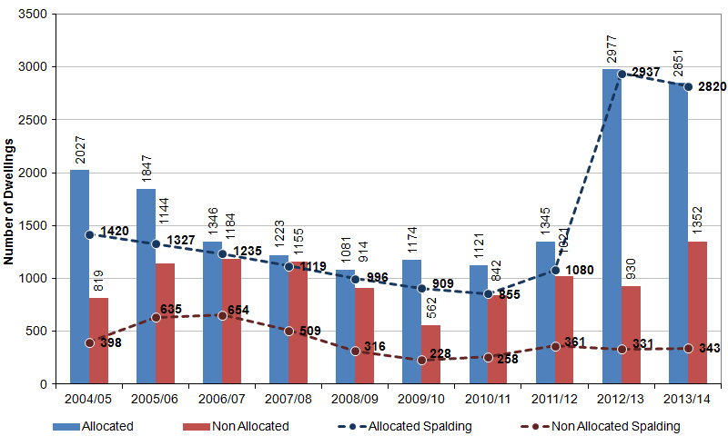

3.14 Indicator L2 - Urban and Rural Housing Completions examines where the majority of housing growth in South East Lincolnshire has taken place.

Figure 8: Urban and Rural Housing Completions in Boston Borough (2004/05 - 2013/14)
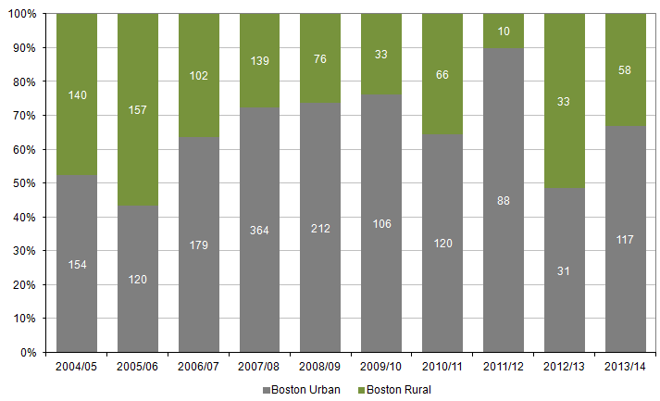

Figure 9: Urban and Rural Housing Completions in South Holland District (2004/05 - 2013/14)
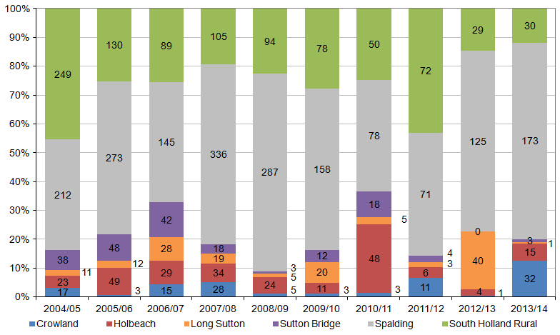

3.15 Indicator L3 - Average density of housing on larger schemes assesses the density (dwellings per hectare) of sites of 10 or more dwellings which have been completed in the financial year. Figure 10 and Figure 11 set out the densities of large schemes completed or approved during 2004/05 - 2013/14.

Figure 10: Average density of housing on large schemes completed in Boston Borough (2004/14)
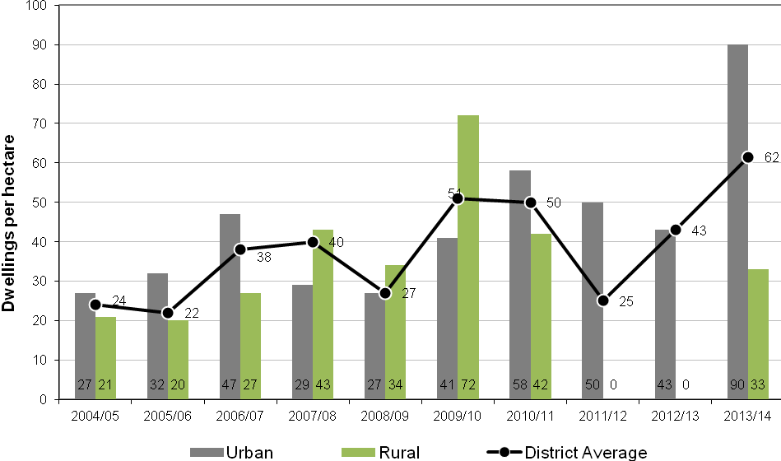

Figure 11: Average density of housing on large schemes completed in South Holland District (2004/14)
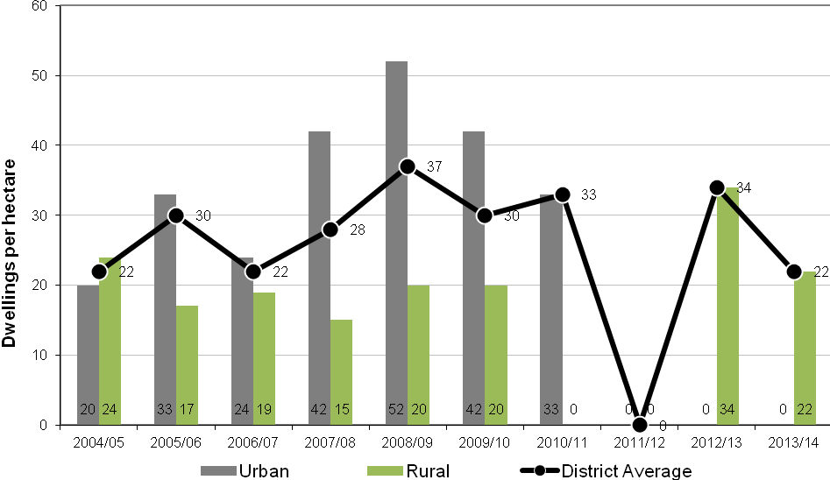

3.16 The next two figures show the average density of housing per hectare on sites of 10 or more dwellings that have received planning permission in the last nine years.

Figure 12: Average density of housing on large schemes approved in Boston Borough (2004/05 - 2013/14)
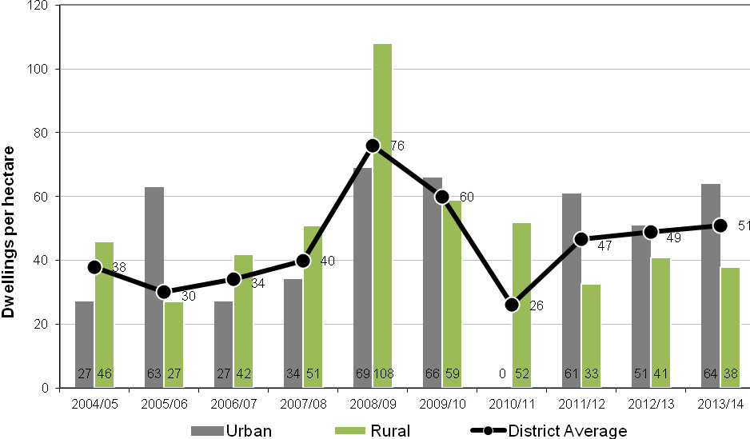

Figure 13: Average density of housing on large schemes approved in South Holland District (2004/05 - 2013/14)
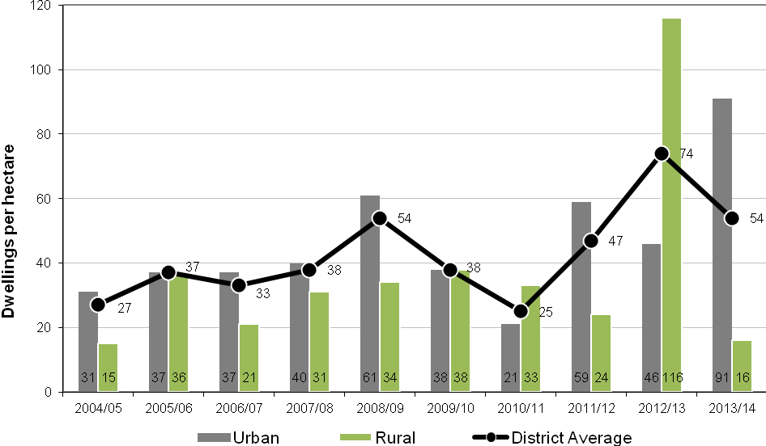

3.17 Indicator L4 - The mix of sizes of housing completed compared with the Strategic Housing Market Assessment (SHMA) in Boston Borough and South Holland District

Figure 14: Number of bedrooms in completed dwellings (Boston Borough)
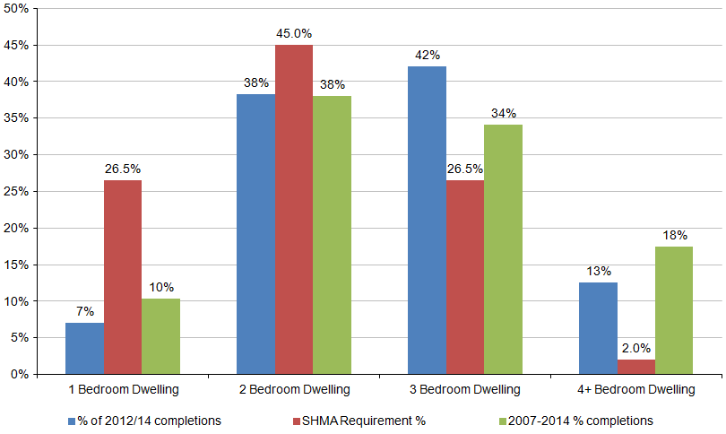

Figure 15: Number of bedrooms in completed dwellings (South Holland District)
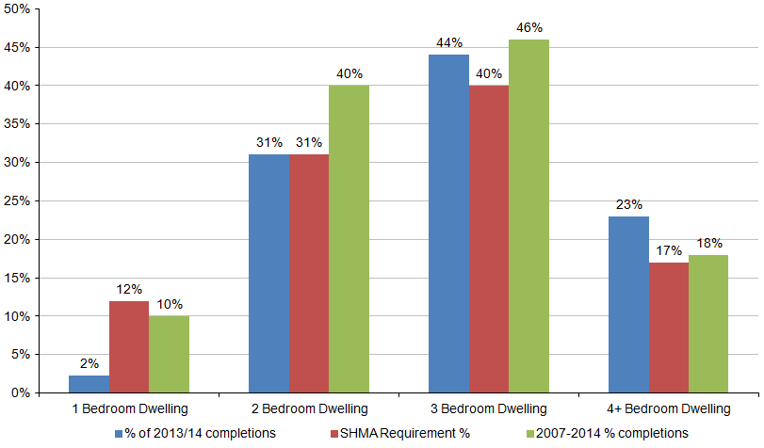

3.18 Indicator L5 - Number of housing applications allowed on appeal provides a general assessment of the success or otherwise of the Local Plan’s housing policies, by examining the number of appeals made, and whether or not those appeals were successful.

Table 18: Housing appeal decisions in South East Lincolnshire (2004/05 – 2013/14)
Year | Number of appeals | Appeals dismissed |  | Appeals allowed
 |  | Number | % | Number | %
2004/05 | 46 | 32 | 70 | 14 | 30
2005/06 | 81 | 63 | 78 | 18 | 22
2006/07 | 41 | 33 | 80 | 8 | 20
2007/08 | 34 | 19 | 56 | 15 | 44
2008/09 | 37 | 23 | 62 | 14 | 38
2009/10 | 18 | 14 | 78 | 4 | 22
2010/11 | 18 | 15 | 83 | 3 | 17
2011/12 | 16 | 12 | 75 | 4 | 25
2012/13 | 13 | 12 | 92 | 1 | 8
2013/14 | 15 | 13 | 87 | 2 | 13

3.19 Indicator L6 - Supply of specific deliverable housing sites indicates to what extent Boston Borough and South Holland District meet the need as set out in the National Planning Policy Framework (NPPF) to provide five years’ supply of housing.

3.20 As of 31st March 2014, South Holland District had 2.9 years and Boston Borough had 2.6 years’ worth of deliverable sites. In the event that a Council cannot demonstrate a five-year supply of deliverable housing sites, it is required to consider favourably planning applications for housing, having regard to the policies in the National Planning Policy Framework.

4 Economy

4.1 This section of the monitoring report reviews the provision and take-up of land for employment uses during the financial year 2013/14. The uses monitored here are set out below and defined in the Town and Country Planning (Use Classes) Order 1987, as amended;

A1 Shops
A2 Financial and professional services
B1 (a) Offices (other than a use within class A2)
B1 (b) Research and development of products or processes
B1 (c) Light industry
B2 General Industry
B8 Storage and distribution

4.2 Although LPAs no longer have to report against Core Output Indicators( COIs), the following COIs will be used in this section;:
- BD1: Total amount of additional employment floor space – by type
- BD2: Total amount of additional employment floor space on previously developed land – by type
- BD3: Employment land available – by type
- BD4: Total amount of floor space for town centre uses

4.3 Other Local Indicators, which reflect aspects that are of particular importance to both Boston Borough and South Holland District, are included as follows:
- L7: Allocated employment land available with no planning permission (Ha)
- L8: Allocated and non-allocated employment land available with planning permission (Ha)
- L9: Floor space on allocated and non-allocated employment land with planning permission (m²)
- L10: Number of vacant ground floor units in town centres
- L11: Number of A1 units in primary shopping frontages
- L12: Town centre pedestrian counts (Boston only)
- L13: Usage of town centre car parks (Boston only)
- L14: Usage of the Port of Boston (Boston only)

4.4 Core Output Indicators

4.5 Indicator BD1 – Total amount of additional employment floor space examines the amount and type of employment floor space completed during the monitored year.

Table 19: Employment floor space (m²) completed
 | B1 (a) | B1 (b) | B1 (c) | B2 | B8 | Mixed | Total
Boston Gross | 1520 | 0 | 5696 | 200 | 251 | 0 | 7667
Boston Net | 1220 | -200 | 5531 | 200 | -2449 | 0 | 4302
South Holland Gross | 1698 | 783 | 887 | 1434 | 402 | 0 | 5204
South Holland Net | 460 | 783 | 887 | 1434 | -3424 | 0 | 140

4.6 Indicator BD2 – Total amount of additional floor space on previously developed land – by type identifies how much of the new employment floor space has been built on previously developed (brownfield) land.

Table 20: Employment floor space (m²) completed on previously developed land
 | B1 (a) | B1 (b) | B1 (c) | B2 | B8 | Mixed | Total
Boston Gross | 0 | 0 | 4375 | 200 | 0 | 0 | 4575
Boston % | 0% | 0% | 79% | 100% | 0% | 0% | 30%
South Holland Gross | 1198 | 783 | 887 | 803 | 402 | 0 | 4073
South Holland % | 71% | 100% | 100% | 56% | 100% | 0% | 78%

4.7 Indicator BD3 – Available new employment land – by type identifies the amount and type of new employment land that remains available for development (land that is either allocated for employment development or for which planning permission is outstanding).

Table 21: Total amount of new employment land (including allocated land with no planning permission and land with planning permission not started).
 | B1 (a) | B1 (b) | B1 (c) | B2 | B8 | Mixed | Total
Boston Borough Hectares | 0.00 | 0.16 | 3.10 | 1.90 | 0.74 | 65.30 | 71.20
South Holland District Hectares | 14.91 | 0.7 | 149.91 | 14.36 | 2.92 | 10.14 | 192.94
Total | 14.91 | 0.86 | 153.01 | 16.26 | 3.66 | 75.44 | 264.14

4.8 Indicator BD4 – Total amount of floor space for town centre uses shows the amount of completed floor space (gross and net) for town centre uses within the local authority area generally.

Table 22: Total amount of completed floor space for town centre uses end March 2013.
 |  | A1 | A2 | B1(a) | D2 | Total
Boston Borough | Gross | 0 | 48 | 0 | 0 | 48
 | Net | -300 | 0 | 0 | 0 | -300
South Holland District | Gross | 0 | 216 | 0 | 712 | 216
 | Net | 0 | 216 | 0 | 712 | 216

4.9 Local Indicators

4.10 Indicator L7 – allocated employment land available without planning permission looks in more detail at the data covered by Core Indicator BD3, and identifies how much of the total available employment land does not have the benefit of a planning permission.

Table 23: Allocated employment land with no planning permission (end March 2013).
Allocated Site | Area Available (Ha)
Boston Borough | 48.89
Enterprise Park, Spalding | 39.75
Crowland | 5.5
Donington | 10.6
Holbeach | 10.1
Long Sutton | 11.31
Wingland | 50.4
Port Sutton Bridge | 13
Total: | 189.55

4.11 Indicator L8 - Allocated and non-allocated employment land available with planning permission (Ha) identifies all land that has the benefit of a planning permission for employment use. [N.B. this indicator includes land that is being recycled from one employment use to another, which is not covered in indicator BD3].

Table 24: Allocated and non-allocated employment land with planning permission (Ha) in Boston Borough.
Site | With Planning Permission |  | Completed during 2013/14
 | Not Started | Under Construction
Boston | 4.83 | 1.95 | 0.76
Kirton* | 17.31 | - | 0.16
Freiston | 0.2 | - | -
Sutterton | 1.7 | 0.17 | -
Swineshead | - | - | -
Non-allocated Sites | 4.47 | 5.02 | 1.81

Table 25: Allocated and non-allocated employment land with planning permission (Ha) in South Holland District.
Site | With Planning Permission |  | Completed during 2013/14
 | Not started | Under Construction
Enterprise Park | 7.2 | 2.4 | 0.74
Crowland | - | - | -
Donington | - | - | -
Holbeach | - | - | -
Long Sutton | - | - | -
Wingland | - | - | -
Port Sutton Bridge | - | - | -
Non-allocated Sites | 217.46 | 14.11 | 8.81

4.12 Indicator L9 – Floor space on allocated and non-allocated employment land with planning permission (m²) identifies the total amount of floor space with planning permission which is committed to development or has been completed during 2013/14 on allocated and non-allocated sites. This includes extensions and redeveloped sites.

Table 26: Floor space on allocated and non-allocated employment land with planning permission (m²) in Boston Borough
Site | With Planning Permission |  | Completed during 2013/14
 | Not Started | Under Construction
Boston | 9497 | 3659 | 1643
Freiston | 634 | - | -
Kirton* | 57820 | 180 | -
Sutterton | 10017 | 363 | -
Swineshead | - | - | -
Non-allocated Sites | 14251 | 8849 | 5844

Table 27: Floor space on allocated and non-allocated employment land with planning permission (m²) in South Holland District
Site | With Planning Permission |  | Completed during 2013/14
 | Not Started | Under Construction
Enterprise Park | 29242 | 6771 | 569
Crowland | - | - | -
Donington | - | - | -
Holbeach | - | - | -
Long Sutton | - | - | -
Wingland | - | - | -
Port Sutton Bridge | - | - | -
Non-allocated Sites | 35462 | 43103 | 4634

4.13 Indicator L10 – Number of vacant ground floor units in town centres looks at a town centre’s health and vitality by monitoring the number of vacant shop units it contains. A hierarchy of town centres in South Holland has been devised for retail policy purposes and the South Holland Local Plan identifies Spalding, Holbeach, Long Sutton, Crowland, Donington and Sutton Bridge as places with defined retail centres’. Boston town centre is the defined retail centre for Boston Borough.

Table 28: Number of vacant ground floor units within town centres
 | 2005 | 2006 | 2007 | 2008 | 2009 | 2010 | 2011 | 2012 | 2013 | 2014
Boston | 39 | 28 | 38 | 48 | 32 | 37 | 28 | 41 | 40 | 36
Kirton | - | - | - | - | - | - | - | - | - | 2
Spalding | 16 | 18 | 21 | 23 | 22 | 29 | 21 | 26 | 20 | Not available
Holbeach | 3 | 3 | 10 | 9 | 13 | 11 | 9 | 5 | 13 | Not available
Long Sutton | 6 | 10 | 9 | 10 | 9 | 9 | 12 | 10 | 9 | Not available
Sutton Bridge | 3 | 5 | 5 | 5 | 7 | 7 | 7 | 7 | 3 | Not available
Crowland | 4 | 4 | 4 | 4 | 6 | 6 | 7 | 4 | 4 | Not available
Donington | 1 | 4 | 4 | 6 | 7 | 5 | 5 | 4 | 4 | Not available
Total | 72 | 72 | 91 | 105 | 96 | 98 | 89 | 97 | 93 | Not available

4.14 Indicator L11 – Number of A1 units in primary shopping frontages seeks to measure the effectiveness of Policies RTC6 and RTC7 of the Boston Borough Local Plan and Policy EC6 of the South Holland Local Plan. These policies state that development proposals resulting in the change of use from retail (Class A1) to non-retail on the ground floors within the primary shopping area will be permitted except where the number or coalescence of such uses would undermine the dominant retail function or harm the vitality or viability of the town centre.

Table 29: number of A1 units in primary shopping frontages
Primary Shopping Area | 2009 |  | 2010 |  | 2011 |  | 2012 |  | 2013 |  | 2014
 | Nº of A1 units | % of A1 units | Nº of A1 units | % of A1 units | Nº of A1 units | % of A1 units | Nº of A1 units | % of A1 units | Nº of A1 units | % of A1 units | Nº of A1 units | % of A1 units
Boston Prime Frontage | 28 | 93% | 28 | 93% | 26 | 81% | 29 | 90% | 22 | 73% | 40 | 82%
Boston Prime Area | 39 | 74% | 37 | 73% | 33 | 60% | 37 | 73% | 39 | 65% | 93 | 61%
Spalding | 36 | 63% | 35 | 61% | 33 | 58% | 35 | 61% | 31 | 54% | Not available | Not available
Holbeach | 26 | 54% | 28 | 58% | 28 | 58% | 28 | 58% | 26 | 54% | Not available | Not available

4.15 Indicator L12 – Town centre pedestrian counts (Boston Only) looks at another of the most obvious measures of a town centre’s health and vitality – the number of people walking through it. Figure 16 (below) shows the total number of pedestrians recorded as passing through Strait Bargate, Boston during monthly surveys conducted on Wednesday Market days. It shows year-on-year increases until 2010/11 followed by a short period of decline, perhaps linked to the recent recession, before recovering last year.

Figure 16: Hourly pedestrian traffic through Strait Bargate on Wednesday Market day (2006/07 – 2013/14)
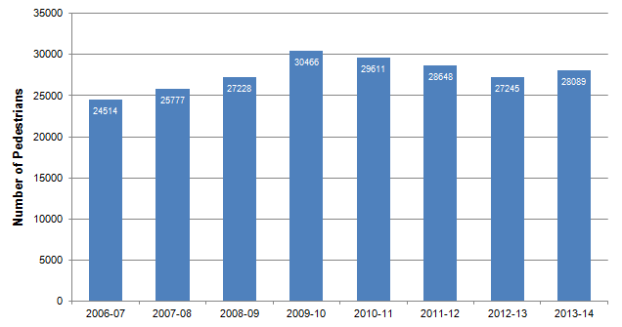

4.16 Indicator L13 – usage of town centre car parks (Boston only) provides another general measure of the town centre’s vitality. Figure 17 (below) shows that the occupancy rate of on street car parking has not varied greatly between 2006 and 2013. In contrast, the use of Borough Council off street car parks declined significantly from 2009 to 2010 (reflecting both the nationwide reduction in vehicle use caused by the recession, as well as the local effects of increase bus usage), but has recovered in more recent years.

Figure 17: Occupancy of Boston’s town centre car parks in October (2004 – 2013).
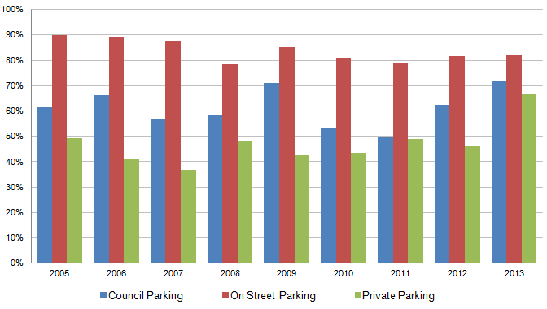

4.17 Indicator L14 – usage of the Port of Boston looks at one of the Borough’s major employers. Figure 18 (below) shows the tonnage of grain, timber, steel, paper and other products being handled. The port continues to do well but saw a reduction in the tonnage handled due to a poor grain harvest resulting in reduced exports for the year to September 2013. The Port of Boston continues to benefit from ample available space and storage areas including grain silos, 18,000 square metres of buildings and a container park. The rail line to the port is allowing larger quantities of materials to be transported by the rail networks.

Figure 18: Total tonnage of grain, timber, steel, paper and other products handled by the Port of Boston (2004 – 2013)
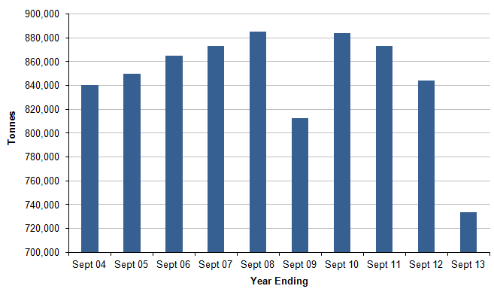

5 Environment

5.1 The purpose of this section of the monitoring report is to monitor progress on environmental and recreational schemes/facilities and assess how effective the Local Plan is in protecting the urban and rural environment

5.2 Core Output Indicators used in this chapter are as follows:

- E1: Number of planning permissions granted contrary to Environment Agency advice on the grounds of flooding or water quality grounds
- E2: Renewable energy generation

5.3 Local Indicators, which reflect aspects that are of particular importance to South East Lincolnshire, are included as follows:

- L15: Biodiversity importance
- L16: Number of Listed Buildings
- L17: Number of buildings on the buildings at risk register
- L18: Provision of open space
- L19: Housing permissions and completions in ROY zones

5.4 Core Output Indicators

5.5 Indicator E1 - Number of planning permissions granted contrary to Environment Agency advice on the grounds of flooding or water quality grounds shows the number of new planning permissions which are potentially located where: they would be at risk of flooding or increase the risk of flooding elsewhere; and/or adversely affect water quality. Table 30 shows the number of planning permissions granted contrary to Environment Agency advice during 2013/14.

Table 30: Number of planning permissions granted contrary to Environment Agency advice
 | Flooding | Quality | Total
Boston  Borough | 2 | 0 | 2
South Holland District | 4 | 0 | 4

5.6 Indicator E2 – Renewable Energy Generation identifies the amount of renewable energy developments/installations that are existing, proposed with planning permission and proposed without planning permission in the South East Lincolnshire area. It provides details on the potential capacity (MW), homes supplied and electricity generated (GWh).

Table 31: Existing and Projected Renewable Energy Development in South East Lincolnshire
Place | Capacity MW | Number of homes supplied | CO₂ Tonnes saved | Annual electricity generated GWh
Existing
Bicker Wind Farm | 26.0 | 14,124 | 37,466 | 61.7
Deeping St Nicholas wind farm | 16.0 | 8,692 | 23,056 | 38.0
Gedney wind farm | 12.0 | 6,519 | 17,292 | 28.5
Pilgrim Hospital bio fuel boiler | 3.0 | N/A | 5,000 | N/A (heat)
Bell Bros bio fuel boiler | 2.0 | N/A | 1,500 | N/A (heat)
Staples anaerobic digester | 3.0 | N/A | Unknown | 23.7
Long Sutton PV | 2.75 | 585 | 1028 | 2.3
Installed PV under FIT | 5.63 | 1216 | 2098 | 4.89
Installed wind under FIT | 0.23 | 135 | Unknown | 0.54
Installed Micro CHP | 0.001 | Unknown | Unknown | Unknown
SUB TOTAL | 70.611 | 31,271 | 87,440 | 159.63
Proposed with Planning Permission
Tydd St.Mary wind farm | 14.0 | 8,000 | Unknown | 32.1
Boston gasification plant | 10.5 | 10,500 | Unknown | 88.2
Leverton PV | 11 | 11,000 | Unknown | 92.4
Fen Road Frampton PV | 1.56 | 1,560 | Unknown | 13.1
Long Sutton PV | 0.79 | 170 | 298 | 0.69
SUB TOTAL | 29.99 | 19,664 | 2,018 | 125.99
Domestic PV | 127.9 | 27,166 | 43,430 | 111.0
Proposed without Planning Permission
Sutton Bridge energy from waste plant | 35.0 | 55,000 | 140,000 | 294.3
Holbeach Marsh wind farm | 16.0 | 7,500 | 21,024 | 35.0
Sutton St.Edmund wind farm | 4.0 | 1,847 | 3,900 | 9.0
SUB TOTAL | 55.0 | 64,347 | 164,924 | 338.3
Total | 283.50 | 142,448 | 297,812 | 734.92

5.7 Local Indicators

5.8 Indicator L15 - Biodiversity importance
At present, South East Lincolnshire has 69 Local Wildlife Sites, 55 of which are considered to be in positive management.

5.9 Indicator L16 - Number of Listed buildings identifies how many buildings are listed as being of special architectural or historic interest in the area. There are a total of 1,023 Listed Building entries in South East Lincolnshire. A single entry may include more than one building or structure. These are an important link to the history and heritage of the area, comprising:

Table 32: Number of Listed Buildings in South East Lincolnshire by Grade.
 | Boston Borough | South Holland District
Grade I | 21 | 24
Grade II* | 24 | 36
Grade II | 450 | 466
Total: | 495 | 526

5.10 Indicator L17 - Number of buildings on the heritage at risk register identifies those Grade I and Grade II* listed buildings, scheduled monuments, registered battlefields, protected wreck sites and registered parks on gardens that are on the English Heritage’s Heritage at Risk Register. Table 33 and 34 (below) outline that in South East Lincolnshire there are;

Table 33: Listed Buildings on the 2013 Heritage at Risk Register (including places of Worship)
Name | Street | Parish | Condition | Occupancy | Grade | Ownership
Crowland Manor | East Street | Crowland | Poor | Part Occupied | II* | Private
Sneaths Mill | Lutton Gowts | Lutton | Fair | Vacant | I | Trust
Old office block of Land Settlement Association | Mallard Road | Spalding | Very bad | Vacant | II* | Private
Church of St.Mary | Barrier Bank | Cowbit | Poor | N/A | I | Religious organisation
The Abbey Church of our Lady | Abbey Walk | Crowland | Poor | N/A | I | Religious organisation
Church of Holy Trinity | Hillgate | Gedney Hill | Poor | N/A | II* | Religious organisation
Broad Street Methodist Church & Sunday school | Broad Street | Spalding | Poor | N/A | II | Religious organisation
Church of St Mary | Main Street | Weston | Very bad | N/A | I | Religious organisation
Church of St.Paul | Holbeach Road | Spalding | Poor | N/A | I | Religious Organisation
All Saints Church | Main Road | Benington | Poor | N/A | I | Religious organisation
Rochford Tower | Rochford Tower Lane | Fishtoft | Very bad | N/A | I | Private
Church of St Peter and St Paul | Church Land | Algarkirk | Very bad | N/A | I | Religious organisation
Church of All Saints | Old Main Road | Fosdyke | Poor | N/A | II | Religious organisation
Church of St Peter and St Paul | High Street | Kirton | Poor | N/A | I | Religious organisation

Table 34: Scheduled Monuments on the 2013 Heritage at Risk Register
Name | Parish | Condition | Principal Vulnerability | Trend | Principal Ownership
Settlement north east of Whitebread Farm | Crowland | Extensive significant problems i.e. under plough, collapse | Arable ploughing | Declining | Private
Settlement north of The Parks | Deeping St. Nicholas | Extensive significant problems i.e. under plough, collapse | Arable ploughing | Declining | Private
Settlement south west of The Parks | Deeping St. Nicholas | Extensive significant problems i.e. under plough, collapse | Arable ploughing | Declining | Private
Settlement south east of Lower Delgate Farm | Weston | Extensive significant problems i.e. under plough, collapse | Arable ploughing | Declining | Private
Multon Hall moated site | Frampton | Extensive significant problems i.e. under plough, collapse | Arable ploughing | Declining | Private

5.11 In addition, the 2013 Heritage at Risk Register identified the conservation areas of Boston, Kirton, Dawsmere and Long Sutton as being at risk.

5.12 Indicator L18 - provision of open space - In May 2012 the South East Lincolnshire Sports Provision and Open Space Assessment was published and the following points are key findings relating to the provision of open space in the area:

- In total there are 6 parks and gardens in South East Lincolnshire with a combined area of 14.11 ha. This amounts to 0.10ha per 1,000 people.
- There are 36 accessible natural and semi-natural green space sites in the area totalling 633.53ha which amounts to 4.41ha per 1,000 people.
- There are 426 amenity green space sites totalling 107.3ha which amounts to 0.75ha per 1,000 people
- 117 children's play sites are available totalling 14.76ha. This amounts to just more than 0.10ha per 1,000 people.
- There are 18 allotment sites comprising 809 plots and totalling 39.47ha. This amounts to 0.27ha per 1,000 people;
- There are 79 cemeteries and churchyards in the area totalling 81.39ha. This amounts to 0.57ha per 1,000 people.

5.13 It was identified that there was a shortage of allotment land in the area and overall facilities needed to be maintained and improved to meet future needs.

5.14 Indicator L19 – Housing permissions and completions by flood hazard zones monitors the amount of residential development proposed or completed in the different flood-hazard zones.

5.15 The decision to monitor the amount of residential development proposed in different flood-hazard zones followed the completion of the Lincolnshire Coastal Study (Coastal Study), which included flood mapping to illustrate the potential hazards arising from tidal flooding. In particular, the Coastal Study cautioned against allowing major housing development in the Red, Orange and Yellow (ROY) flood-hazard zones.

5.16 The flood-hazard classification featured in the Coastal Study is split into five categories, defined by the depth and velocity of flood waters and the related ability of people to evacuate the area once a flood occurs. Please see Figure 19 below for a description of flood-hazard zones. Table 35 below identifies the number of housing permissions and completions across South East Lincolnshire in the different zones.

Figure 19: Flood-hazard classification used in the Lincolnshire Coastal Study
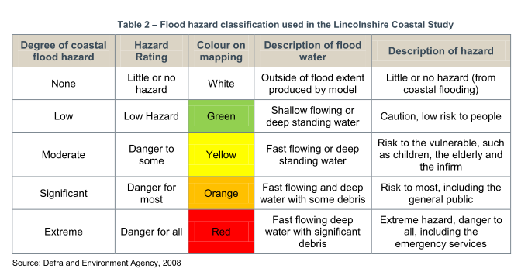

Table 35: Housing permissions and completions across South East Lincolnshire by flood hazard zones (2013 - 2014)

 | Permissions | Completions
White | 648 | 261
Green | 30 | 11
Yellow | 5 | 34
Orange | 390 | 46
Red | 15 | 85
Total | 1088 | 437

2001 Census, ONS mid-year population estimates, *revised ONS 2008 population estimates and 2011 Census.
Office for National Statistics (ONS) (2011) ‘2011 Census Quality Assurance Pack’, available at: http://www.ons.gov.uk/ons/publications/re-reference-tables.html?edition=tcm%3A77-257414 Accessed 17/07/2012
Office for National Statistics (ONS) (2012) ‘Mid-2012, Population Estimates for England and Wales, available at: http://www.ons.gov.uk/ons/publications/re-reference-tables.html?edition=tcm%3A77-310118 , Accessed 25/02/2014
Economic activity is a measure of those aged 16-64 who are of working age, in work or seeking work.
Office for National Statistics (ONS) (2011) ‘2011 Census: KS601EW Economic Activity’, available at: http://www.ons.gov.uk/ons/search/index.html?pageSize=50&sortBy=none&sortDirection=none&newquery=economically+active+in+South+Holland , accessed: 22/02/2013.
Office for National Statistics (ONS) (2011) ‘2011 Census: KS501EW Qualifications’, available at: http://www.ons.gov.uk/ons/search/index.html?newquery=KS501EW, Accessed 22/02/2013.
Level 1 is 1-4 GCSEs, Level 2 is 5+ GCSEs/Apprenticeships, Level 3 is 2+ A Levels, Level 4 is degree and other includes non UK qualifications.
ONS Neighbourhood Statistics (2011) Industry of Employment; All people, available at: http://www.ons.gov.uk/ons/publications/re-reference-tables.html?newquery=*&newoffset=25&pageSize=25&edition=tcm%3A77-286262 Accessed 14/12/2012.
nomis Official Labour Market Statistics (2011), available at: http://www.nomisweb.co.uk/reports/lmp/la/contents.aspx, Accessed 10/07/2013.
ONS Neighbourhood Statistics (2011) Car or Van availability, available at: http://www.ons.gov.uk/ons/publications/re-reference-tables.html?newquery=*&newoffset=0&pageSize=25&edition=tcm%3A77-286262, Accessed 14/12/2012
Office for National Statistics (ONS) (2011) ‘2011 Census: CT0015 Method of travel to work’, Accessed http://www.ons.gov.uk/ons/search/index.html?pageSize=50&sortBy=none&sortDirection=none&newquery=economically+active+in+South+Holland, Accessed 22/02/2013.
The Royal Society for the Protection of Birds (RSPB) (2012) ‘Reserves by name’, available at: http://www,rspb.org.uk/reserves/guide/f/, Accessed 15/08/2012
Natural England (2012) Local Nature Reserves, available at: http://www.lnr.naturalengland.org.uk, Accessed 15/08/2012
English Heritage (2013) Heritage Counts 2013, available at: http://hc.english-heritage.org.uk/content/pub/2013/understanding-assets-2013.xls , Accessed 17/02/2014.
English Heritage (2013) Heritage at Risk Register 2013, available at: http://risk.english-heritage.org.uk/register.aspx?rs=1&rt=0&pn=1&st=a&di=South+Holland&ctype=all&crit= , Accessed 17/02/2014.
The NPPF (page 50) states “intermediate housing is homes for sale and rent provided at a cost above social rent but below market levels subject to the criteria in the Affordable Housing definition above. These can include shared equity (shared ownership and equity loans), other low cost homes for sale and intermediate rent, but not affordable rented housing “
Boston Urban comprises of the town of Boston and urban parts of the Fishtoft and Wyberton Wards
DCLG (2012) National Planning Policy Framework, available at: http://www.communities.gov.uk/documents/planningandbuilding/pdf/2116950.pdf, Accessed 22/08/2012.
NPPF 6 year Housing land Supply Assessment for South Holland District Council as at 31 March 2014, available at: http://www.southeastlincslocalplan.org/housing/
* Land that is available at Kirton Distribution Park
Please not that this does not include floorspace on one site as this is an outline planning permission and is not providing the detailed information on floorspace and use class until the Reserved Matters stage.
SELJPU (2012) Sustainability Appraisal Scoping Report, available at: http://southeastlincslocalplan.org/files/2012/07/Strategy-and-Policies-DPD-Final-Scoping-Report-July-2012.pdf Accessed 28/08/2012
GLNP (2012-2013) ‘Local Sites reporting - Indicator 160-00’.
English Heritage (2013) Heritage Counts 2013, Available at http://hc.english-heritage.org.uk/content/pub/2013/understanding-assets-2013.xls , Accessed 17/02/2014.
English Heritage (2013) Heritage at Risk Register 2013, Available at: http://risk.english-heritage.org.uk/register.aspx?rs=1&rt=0&pn=1&st=a&di=South+Holland&co=Lincolnshire&re=East+Midlands&ctype=all&crit= Accessed on 20/08/2012.
English Heritage (2013) ‘Heritage at Risk Register’, available at: http://risk.english-heritage.org.uk/register.aspx?rs=1&rt=0&pn=1&st=a&di=South+Holland&ctype=all&crit= accessed 17/02/2014.
English Heritage (2013) ‘Heritage at Risk Register’ available at: http://risk.english-heritage.org.uk/register.aspx?rs=1&rt=0&pn=1&st=a&di=South+Holland&ctype=all&crit= accessed 17/02/2014

